­

SYSTEM

REQUIREMENTS

SPECIFICATION

PHYSIOMATIC

**Software Develpment Crafters**

**Version 0.1**

**December 26th, 2020**

[eapaez3@espe.edu.ec](mailto:eapaez3@espe.edu.ec)

[aspaguay@espe.edu.ec](mailto:aspaguay@espe.edu.ec)

[bdpatino@espe.edu.ec](mailto:bdpatino@espe.edu.ec)

[sfrisueno@espe.edu.ec](mailto:sfrisueno@espe.edu.ec)

Índice

1. INTRODUCTION 3

1.1. PROJECT’S PURPOSE 3

1.2. PRODUCT SCOPE 3

1.3. INVOLVED PEOPLE 3

1.4. GLOSSARY 4

1.5. REFERENCES 4

1.6. OVERVIEW 4

2. GENERAL DESCRIPTION 5

2.1. PRODUCT PERSPECTIVE 5

2.2. PRODUCT FUNCTIONS 5

2.3. USER CHARACTERISTICS 5

2.4. CONSTRAINTS 5

2.5. ASSUMPTIONS AND DEPENDENCIES 6

3. SPECIFIC REQUIREMENTS 6

FUNCTIONAL REQUIREMENTS 6

NON-FUNCTIONAL REQUIREMENTS 9

3.1. COMMON INTERFACE REQUIREMENTS 10

3.1.1. USER INTERFACES 10

3.1.2. HARDWARE INTERFACES 10

3.1.3. SOFTWARE INTERFACES 10

3.2. FUNCTIONAL REQUIREMENTS 10

3.2.1. FUNCTIONAL REQUIREMENT 1 10

3.2.2. FUNCTIONAL REQUIREMENT 2 11

3.2.3. FUNCTIONAL REQUIREMENT 3 11

3.2.4. FUNCTIONAL REQUIREMENT 4 11

3.2.5. FUNCTIONAL REQUIREMENT 5 11

3.2.6. FUNCTIONAL REQUIREMENT 6 11

3.2.7. FUNCTIONAL REQUIREMENT 7 11

3.2.8. FUNCTIONAL REQUIREMENT 8 12

3.3. NON-FUNCTIONAL REQUIREMENTS 12

3.3.1. NON-FUNCTIONAL REQUIREMENT 1 12

3.3.2. NON-FUNCTIONAL REQUIREMENT 2 12

# INTRODUCTION

This document is the System Requirements Specification for an appointment management system and patient medical records of a physical therapy center. This specification has been structured based on the guidelines given by the IEEE 830 standard.

## 1.1. PROJECT’S PURPOSE

The purpose of this document is to define the functional and non-functional specifications for the development of a system for organizing appointments and medical records of patients in a physiotherapy center. This system will be used by the physiotherapist.

## 1.2. PRODUCT SCOPE

This specification of requirements is directed to the user of the system, to manage an orderly system of appointments and records, whose main objective is to organize the different administrative processes (Appointments, Medical History, Report).

## 1.3. INVOLVED PEOPLE

|  |  |
| --- | --- |
| **Name** | Adrián Páez |
| **Rol** | Programmer |
| **Career** | Software Engineering |
| **Responsibility** | Designer and programmer |
| **Contact** | eapaez3@espe.edu.ec |

|  |  |
| --- | --- |
| **Name** | Paguay flores Alex Santiago |
| **Rol** | Analyst and Programmer |
| **Career** | Software Engineering |
| **Responsibility** | Information analyst, designer and programmer |
| **Contact** | aspaguay@espe.edu.ec |

|  |  |
| --- | --- |
| **Name** | Brayan Daniel Patiño Abad |
| **Rol** | Analyst and Programmer |
| **Career** | Software Engineering |
| **Responsibility** | Information analyst, designer and programmer. |
| **Contact** | bdpatino@espe.edu.ec |

|  |  |
| --- | --- |
| **Name** | Santiago Fabian Risueño Zapata |
| **Rol** | Analyst and Programmer |
| **Career** | Software Engineering |
| **Responsibility** | Programmer |
| **Contact** | sfrisueno@espe.edu.ec |

## 1.4. GLOSSARY

This subsection contains definitions of all the terms, acronyms, and abbreviations used in the document. Terms and concepts from the application domain are defined.

## 1.5. REFERENCES

* IEEE 830 - 1998

## 1.6. OVERVIEW

This document consists of three sections. In the first, a brief introduction is given, providing an overview about the specification of system resources.

In the second, a more detailed description of the system is made, in order to know the main functionalities that it must perform, the most relevant and associated data and factors, restrictions and dependencies that directly affect development.

Finally, the last section defines in detail the requirements (functional and non-functional) that the proposed system must satisfy.

# GENERAL DESCRIPTION

## 2.1. PRODUCT PERSPECTIVE

The Physiomatic system will be designed to get a better organization, which will allow the physiotherapy specialist to have better efficiency in his office, and through this, in his private life.

## 2.2. PRODUCT FUNCTIONS

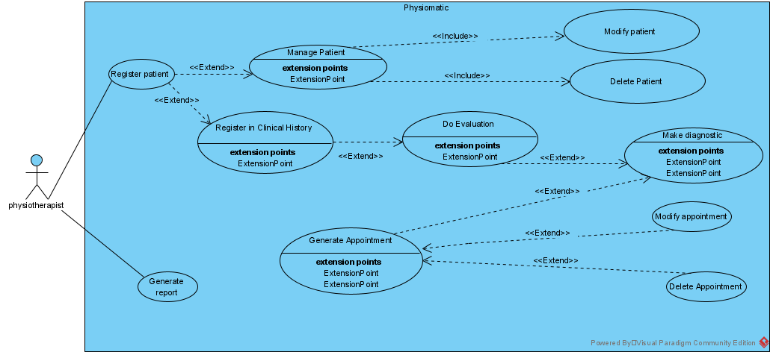

## 2.3. USER CHARACTERISTICS

There is a type of user in the system “the physiotherapist”. He can create a patient, when he is created, he will be able to modify or delete him. When a patient is created, the physiotherapist can register in Clinical History. After he can do an evaluation of the patient and make a diagnostic. Finally the physiotherapist generates an appointment and gives it to the patient.

|  |  |
| --- | --- |
| **TYPE OF USER** | Physiotherapist |
| **EDUCATION** | Doctor |
| **ACTIVITIES** | take care for patients with physical problems |

## 2.4. CONSTRAINTS

* System is to be developed in Java through Servelets and JSP pages
* Data must be stored in a relational database for quick queries and storage.
* Passwords must be sent and stored in encrypted form.

## 2.5. ASSUMPTIONS AND DEPENDENCIES

* System will be installed on a machine running Windows operating system and java
* The computers on which the system is to be run must meet the requirements indicated to guarantee its correct execution.

# SPECIFIC REQUIREMENTS

## FUNCTIONAL REQUIREMENTS

|  |  |
| --- | --- |
| **ID REQUIREMENT** | FR01 |
| **REQUIREMENT’S NAME** | User authentication |
| **CHARACTERISTICS** | The system will allow the validation of user data to allow access to the system. |
| **DESCRIPTION** | The system manages the user and their password, which allow the user to acces the system. |
| **PRIORITY** | High |

|  |  |
| --- | --- |
| **ID REQUIREMENT** | FR02 |
| **REQUIREMENT’S NAME** | Registering patient data |
| **CHARACTERISTICS** | It will allow the physiotherapist to register the new patients’ data. |
| **DESCRIPTION** | The physiotherapist will be able to register new patients with their data that will be saved in a database. |
| **PRIORITY** | High |

|  |  |
| --- | --- |
| **ID REQUIREMENT** | FR03 |
| **REQUIREMENT’S NAME** | Manage patient data |
| **CHARACTERISTICS** | The system will allow the user to manage patients’ data. |
| **DESCRIPTION** | It will allow the user to modify data or delete existing patient records in the database. |
| **PRIORITY** | High |

|  |  |
| --- | --- |
| **ID REQUIREMENT** | FR04 |
| **REQUIREMENT’S NAME** | Registration in clinical history |
| **CHARACTERISTICS** | The system will allow the creation of the clinical history of registered patients. |
| **DESCRIPTION** | The system will allow the physioterapist to register the current pathology of the patients, history and evolution. |
| **PRIORITY** | High |

|  |  |
| --- | --- |
| **ID REQUIREMENT** | FR05 |
| **REQUIREMENT’S NAME** | Register diagnostic |
| **CHARACTERISTICS** | The system will allow to record the physioterapeutic diagnosis of the patient. |
| **DESCRIPTION** | The system will allow the physiotherapist to record the evoluation of the pathology, the treatment and necessary medication. |
| **PRIORITY** | High |

|  |  |
| --- | --- |
| **ID REQUIREMENT** | FR06 |
| **REQUIREMENT’S NAME** | Appointment creation |
| **CHARACTERISTICS** | The system will allow you to create the appointment for the patient. |
| **DESCRIPTION** | The system will allow the physiotherapist to create an appoinment in the corresponding area at the available times. |
| **PRIORITY** | High |

|  |  |
| --- | --- |
| **ID REQUIREMENT** | FR07 |
| **REQUIREMENT’S NAME** | Appointment management |
| **CHARACTERISTICS** | The system will allow you to manage the appoinments created. |
| **DESCRIPTION** | The system will allow appointments to be modified in the event of problems with patients in attendance. |
| **PRIORITY** | High |

|  |  |
| --- | --- |
| **ID REQUIREMENT** | FR08 |
| **REQUIREMENT’S NAME** | Appointment Calendar |
| **CHARACTERISTICS** | The system will allow you to view the medical appointments planned at different times. |
| **DESCRIPTION** | The system will allow the physiotherapist to view an appointment calendar with scheduled, overdue, attended appointments and the available times. |
| **PRIORITY** | High |

## NON-FUNCTIONAL REQUIREMENTS

|  |  |
| --- | --- |
| **ID REQUIREMENT** | NFR01 |
| **REQUIREMENT’S NAME** | System Interface |
| **CHARACTERISTICS** | The system will have a friendly interface with the user. |
| **DESCRIPTION** | The system will display a friendly range of colors with clear messages and buttons that allow easy manipulation of the system. |
| **PRIORITY** | High |

|  |  |
| --- | --- |
| **ID REQUIREMENT** | NFR02 |
| **REQUIREMENT’S NAME** | User Manual |
| **CHARACTERISTICS** | The system will allow the user to have a Fisiomatic user manual. |
| **DESCRIPTION** | The system will display information about its available processes and functions. |
| **PRIORITY** | High |

## 3.1. COMMON INTERFACE REQUIREMENTS

### 3.1.1. USER INTERFACES

The user interface will consist of a window where you will have several options, such as: scheduling an appointment, reviewing the medical history of a patient, generating a final invoice, etc. This must be built specifically for the proposed system and will be viewed from a computer.

### 3.1.2. HARDWARE INTERFACES

It will be necessary to have computer equipment in perfect condition with the following characteristics:

· 1.66GHz processor or higher.

· Minimum memory of 256Mb.

· Mouse.

· Keyboard.

. Printer.

### 3.1.3. SOFTWARE INTERFACES

**·**  Operating System: Windows XP or higher.

· Java script, JRE.

## 3.2. FUNCTIONAL REQUIREMENTS

### 3.2.1. FUNCTIONAL REQUIREMENT 1

* **USER AUTHENTICATION:** The user must identify himself with the username and password generated to access the system.
* The system can only be consulted by the physiotherapist who has a registered username and password.

### 3.2.2. FUNCTIONAL REQUIREMENT 2

* **REGISTERING PATIENT DATA:** The physiotherapist must enter the data of the new patients in a database by keyboard.

### 3.2.3. FUNCTIONAL REQUIREMENT 3

* **MANAGE PATIENT DATA:** The physiotherapist will be able to manage the data of the created patients:
  + Modify data: The system will allow access to the saved data and make changes if necessary.
  + Delete a patient record: The system will allow the physiotherapist to delete a patient´s record in case it has been entered wrongly or duplicated.

### 3.2.4. FUNCTIONAL REQUIREMENT 4

* **REGISTRATION IN CLINICAL HISTORY:** The physiotherapist must record the pathology, antecedents and the evolution that he has had during the care process.
  + In addition, the physiotherapist will have the possibility to modify or delete the stored data as appropriate.

### 3.2.5. FUNCTIONAL REQUIREMENT 5

* **REGISTER DIAGNOSTIC:** After the physiotherapeutic evaluation, the system will allow the user to register:
  + Pathology.
  + Treatment.
  + Medication.

### 3.2.6. FUNCTIONAL REQUIREMENT 6

* **APPOINTMENT CREATION:** The physiotherapist may create database appointments according to the disposition of the medical agenda.
* To facilitate viewing the available schedules, each scheduled appointment will be displayed in calendar, weekly or monthly mode, with date and time.

### 3.2.7. FUNCTIONAL REQUIREMENT 7

**APPOINTMENT MANAGEMENT:** The physiotherapist will be able to manage the data of the created appointments, such as:

* + Modify appointment date and time: The system will allow access to the appointments created, in order to modify the date and time, if necessary.
  + Delete an appointment: The system will allow the physiotherapist to delete an appointment, in case it is canceled by the patient humself.

### 3.2.8. FUNCTIONAL REQUIREMENT 8

* **APPOINTMENT CALENDAR:** The system will display a calendar with the following information:
  + Scheduled appointments.
  + Appointments made.
  + Missed appointments.
  + Hours available.

## 3.3. NON-FUNCTIONAL REQUIREMENTS

### 3.3.1. NON-FUNCTIONAL REQUIREMENT 1

* **SYSTEM INTERFACE:** The system will display a friendly and intuitive interface, with clear messages and buttons that will allow optimal navigation within it.

### 3.3.2. NON-FUNCTIONAL REQUIREMENT 2

* **USER MANUAL:** The system will have a user manual that will specify the processes and functions that exist within it.
* This manual will be easy to undestand, since it will contain images and their respective description to be able to use it.